Profiling of Real-Time

Translucency

Sam Oates

Average Render Time with Everything on (30 fps) (Culling Enabled)

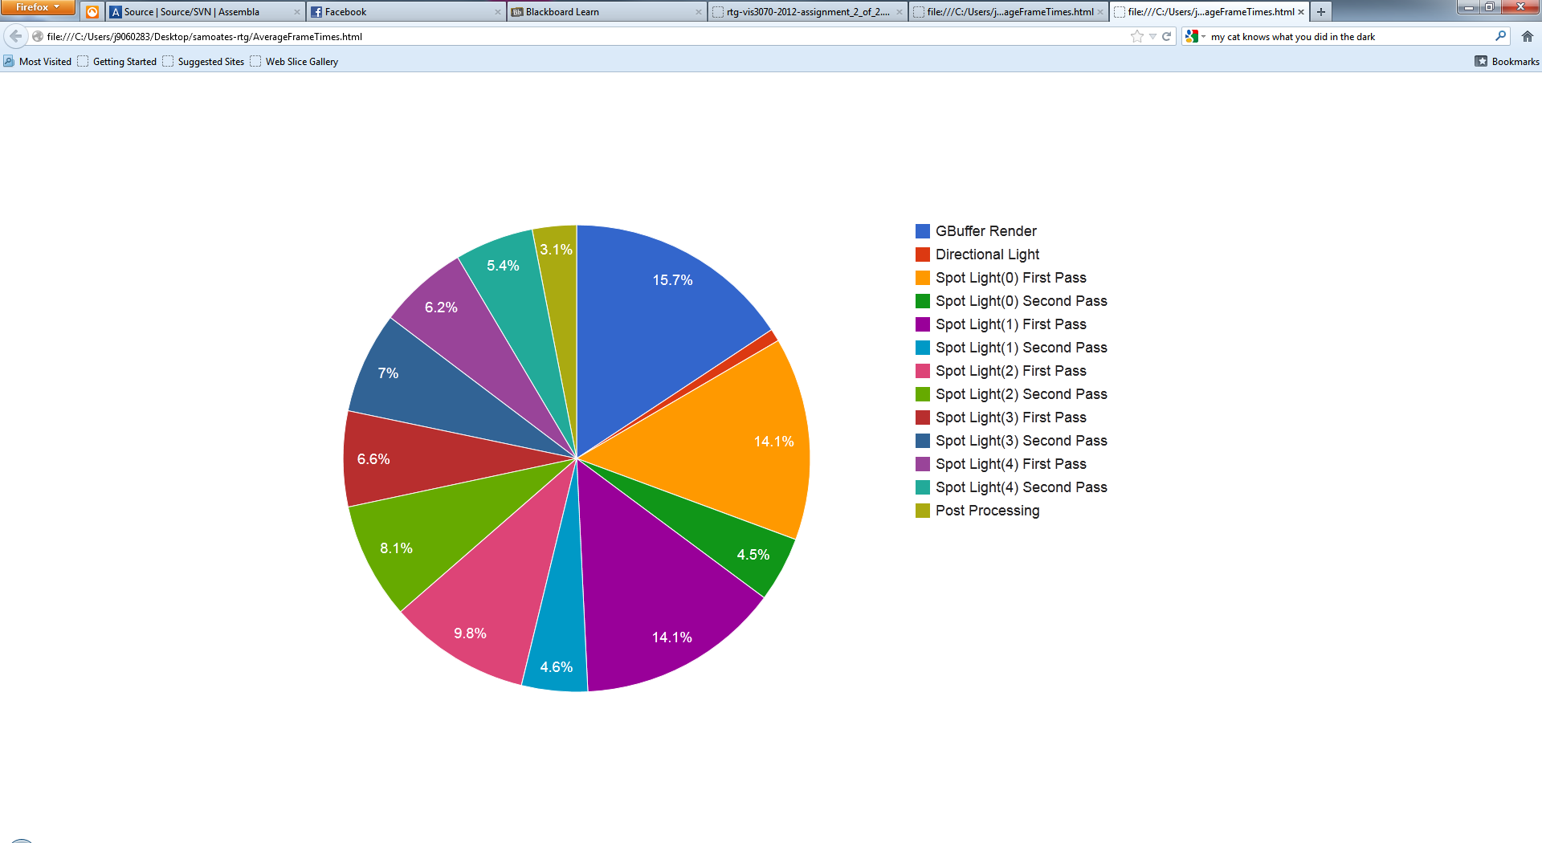

Spotlight fragment shader returning with no calculations (60 fps)

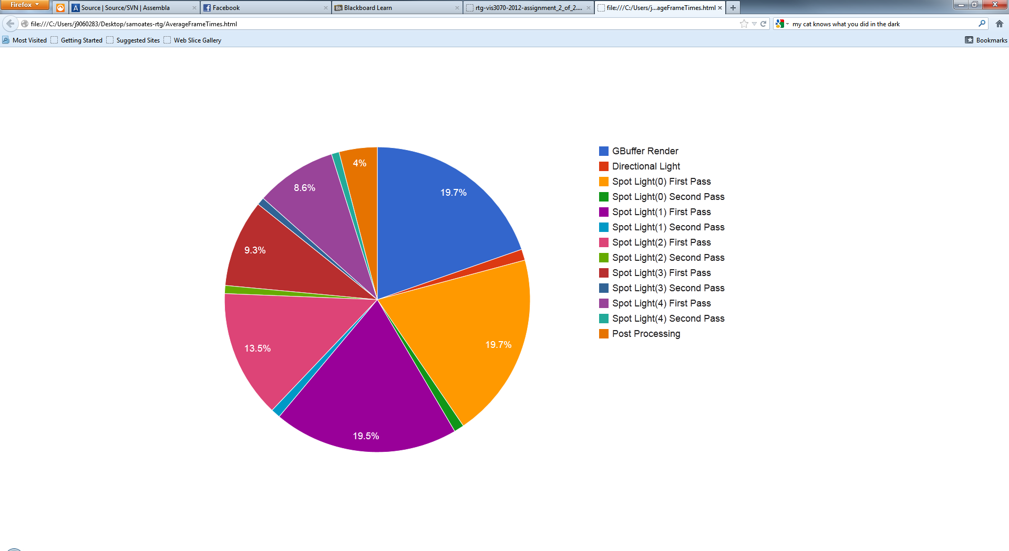

Average Render Time with Everything on (25 fps) (Culling Disabled)

